**Long Rifles of The Canadian**

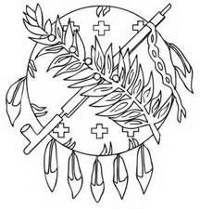**Oklahoma State**

**Muzzleloading**

**Shoot**

# May 22-May 24, 2026

# **Certificates – Individual Matches 1-3 Places**

**Certificates & Prizes – Aggs. 1-3 Places**

## Muzzleloading Range at Oklahoma City Gun Club

Firing will start Friday and Saturday at 8:00 am until 4:00 pm.

Sunday 8:00 am until 11:00 am. No relay started after 11:00 am Sunday.

Covered Firing Line, Camping and RV spaces (Limited Electric—First come basis), No Potable Water! Water is available but not for drinking!

**Registration:** Registration Fee $15.00. Aggregates Entry by aggregate only at $2.00

per match: No charge for Oklahoma State Championship Aggs. Daily Rifle, Pistol and Bench Matches $2.00.

**Camping Fees: $10.00** per camp for electric hook-up only. Dry camp no charge. Campers can set-up after 12:00 pm on Thursday May 22nd.

**Traders Welcome! No charges for traders to camp or trade.**